

|  |
| --- |
| TURTLE WHIPS  TECHNICAL REFERENCE |

|  |  |  |
| --- | --- | --- |
| Future Turtles 2026 |  |  |
|  |  |  |

# GETTING READY

Gather:

* 24 whips (6’ tall LED poles)
  + Whips are stored in two large ski duffel bags
  + We have a couple of extra backup poles, which are marked “backup only”. Use these as a last resort.
* 24 cups

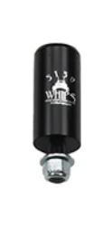

* 24 tripods

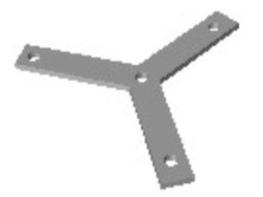

* 72 lag screws
  + The same as what we use in camp for everything: 14” long, 3/8” diameter screws
* The cable harness, which consists of 24 individual controllers and two large power boxes, all wired together.

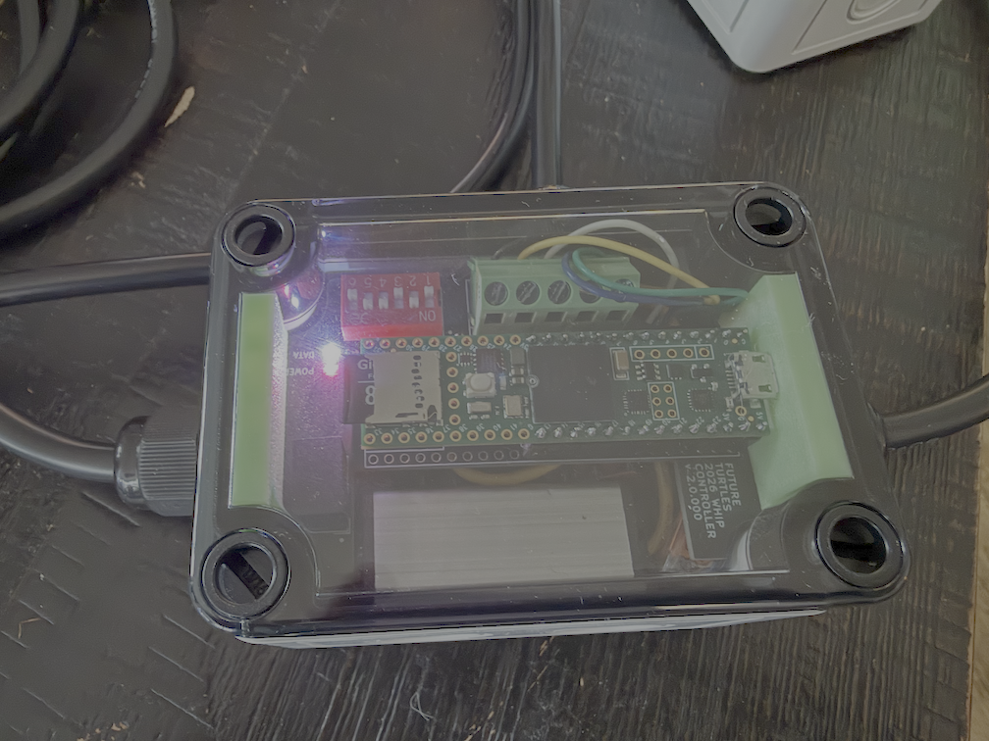 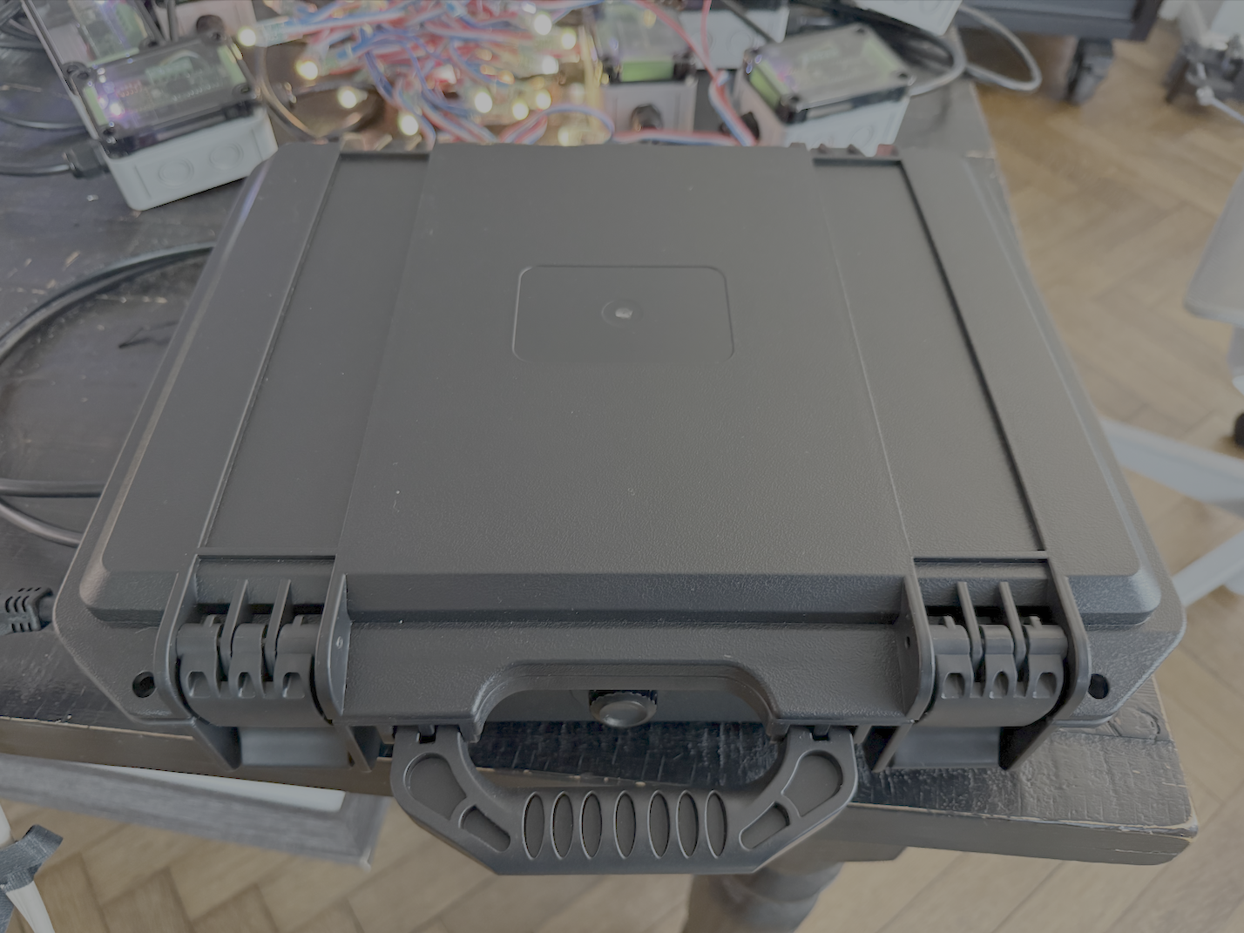

* Two extension cords, length as needed, to plug the power boxes in AC power at the nearest spider box
* Two small Sockitboxes to waterproof the extension cord connection point:

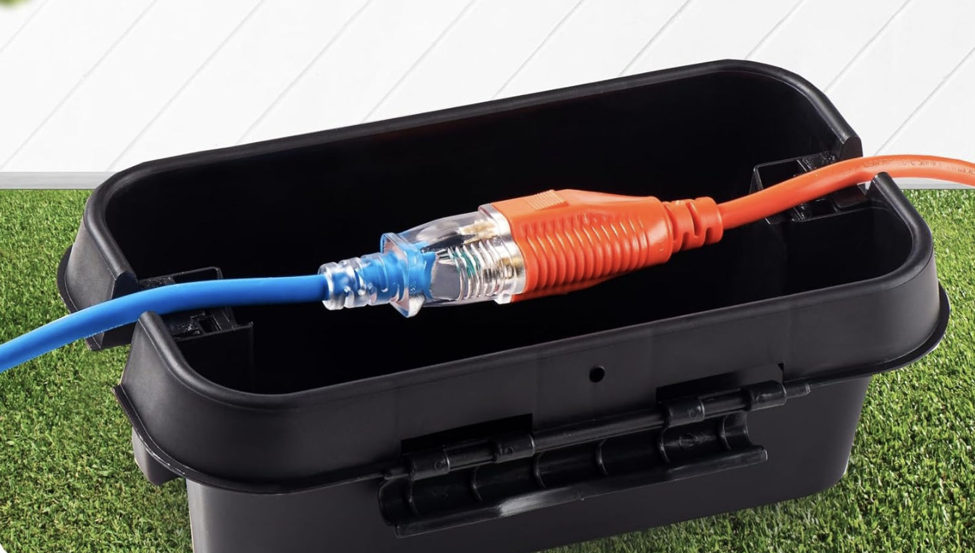

Tools you will need:

* Measuring tape
* Impact driver (to screw lag screws into the ground)
* 75’ of string (to mark a straight line)

# PHYSICAL INSTALLATION

## Layout

There are 24 whips which must be placed 32” apart.

* Stretch out a temporary piece of landscape string perfectly taut to get a straight line where the whips will go.

## Physical Mount

Each antenna whip slips smoothly into a **mounting cup** which holds it straight.



Each cup is attached with its built-in #12 bolt to the center of a **tripod**:



The tripod has three holes for three (3) camp-standard 14” lag screws to secure it to the ground. Lag screws should be drilled into the ground using an impact wrench.

## Cable Harness

The cable harness consists of 2 large power boxes and 24 small controllers (one for each whip), all pre-wired. The entire cable system is waterproof.

## Layout

Whips are numbered from 0 to 23. The small controllers and the power boxes will go right behind them so they don’t present a tripping hazard.

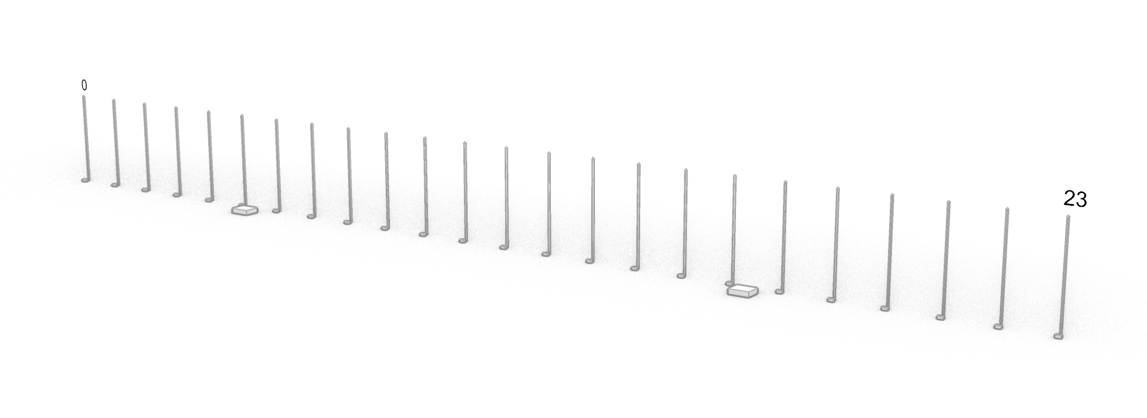

The first large power box will end up between whip 5 and 6, and the second one will end up between whip 17 and 18.

## Plugging things in

1. Each whip has a male XLR plug which plugs into the female XLR of the controller.
2. Both power boxes must be plugged into AC power. They have very short cords so you’ll need extension cords to reach the nearest spider box. Make sure that the connection to the extension cord is in a small waterproof sockitbox.

## First Run and Test

Once you connect everything, all 24 whips should start showing patterns. Find the remote control, stored in the first power box. You can point this at the electronics inside that box.

Click the **FLASH** button on the remote control. This causes the whips to display, in binary, their position number. This can be used to ensure that each whip is showing the right part of the image. This is how it should look:

|  |  |  |  |  |  |  |  |  |  |  |  |  |  |  |  |  |  |  |  |  |  |  |  |
| --- | --- | --- | --- | --- | --- | --- | --- | --- | --- | --- | --- | --- | --- | --- | --- | --- | --- | --- | --- | --- | --- | --- | --- |
| 0 | 1 | 2 | 3 | 4 | 5 | 6 | 7 | 8 | 9 | 10 | 11 | 12 | 13 | 14 | 15 | 16 | 17 | 18 | 19 | 20 | 21 | 22 | 23 |
|  |  |  |  |  |  |  |  |  |  |  |  |  |  |  |  |  |  |  |  |  |  |  |  |
|  |  |  |  |  |  |  |  |  |  |  |  |  |  |  |  |  |  |  |  |  |  |  |  |
|  |  |  |  |  |  |  |  |  |  |  |  |  |  |  |  |  |  |  |  |  |  |  |  |
|  |  |  |  |  |  |  |  |  |  |  |  |  |  |  |  |  |  |  |  |  |  |  |  |
|  |  |  |  |  |  |  |  |  |  |  |  |  |  |  |  |  |  |  |  |  |  |  |  |

If the binary display for any whip is not correct, open that whip’s small controller box with a screwdriver, and adjust the red and white DIP switch (see DIP Switch Adjustment, below)

Click the Red, Green, Blue, and White buttons on the remote control, and ensure that every whip is showing the appropriate solid colors.

Click the Play button on the remote control to start displaying patterns. Wait until night and then adjust the brightness with the brightness up/down buttons until it looks great. Take some pictures for posterity.

## DIP Switch Adjustment

Inside each small controller is a circuit board that looks like this:

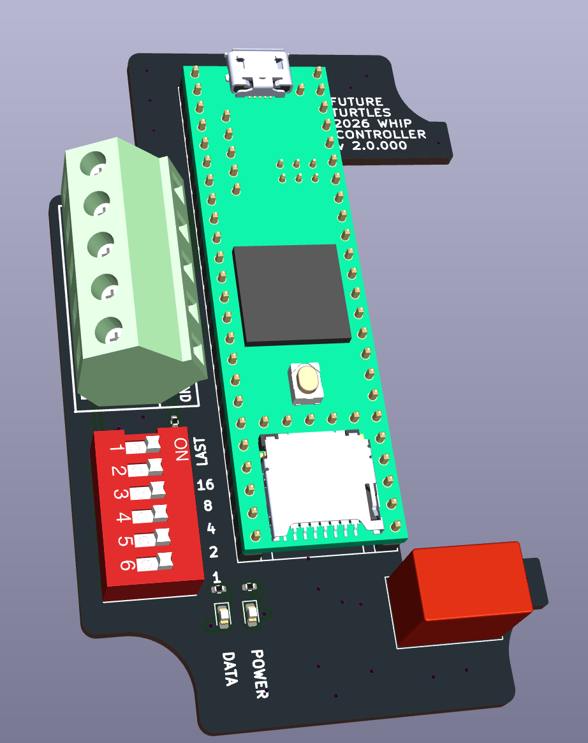

DIP switch

The red and white DIP switch tells the controller which whip it is responsible for, from 0 to 23, using binary.

**The DIP switches should already be pre-set, so you’re only going to need to adjust them if you have rewired something or replaced a faulty circuit board.**

The red and white DIP switch has 6 toggles which you can flip with a small screwdriver.

The labels that matter are printed on the circuit board, not the switch. Those are **LAST, 16, 8, 4, 2,** and **1.** For example, suppose you want a controller to control whip number 13. You would then turn on switch **8, 4,** and **1** because 8 + 4 + 1 = **13**.

**LAST** is a special switch that tells the controller that it is responsible for either **0** or **23**. For every other position, it should be off. (Turning on **LAST** adds a 100-ohm terminating resistor to the communications channel to eliminate ringing from the end of the line.)

# TROUBLESHOOTING TIPS

*Check power to the AC transformers*

Open each of the black boxes that provide power. The AC transformer is a large silver brick. Check that there is a blue light on the main AC transformer.

**No power?** Follow the extension cord back and make sure it’s plugged into something with power, probably a spider box. A common problem is that the power breaker has flipper or that the GFCI has flipped and you need to press a RESET button to get power. Another common problem is that the spider box is not hooked up to the generator or that the generator is off.

*Check that the primary controller is working.*

Each of the black boxes has one controller in it. The first one is labeled **Primary Controller,** and the second one is labeled **Backup Controller**.

**ONLY ONE CONTROLLER CAN BE USED.** Normally, the primary controller is used. You know that it is working because there is a tiny red LED glowing inside on its circuit board. The backup controller will be disconnected from power.

*If the primary controller fails, you can disconnect it from 5V power and connect the backup controller to 5V power. Don’t ever try to have both controllers running at once!*

*Check that all the small controllers have power and data.*

The small controllers have two tiny lights that you can see through the top panel.

A red **POWER** light tells you that this controller, in particular, its microcontroller, has power.

A white **DATA** light, when flickering, indicates that data is being received at this controller.

**Power** is transmitted over red and black wires between the controllers. Data is transmitted over white and yellow wires between the controllers.

If you see a whole group of whips that aren’t receiving data or power, it’s likely to be a connection problem on the power or data lines that connect the controllers. For example, if whips 0, 1, and 2 are not receiving power, but the rest are, it’s likely to be a problem at the connection between controller 2 and controller 3.

On the other hand, if you just have a single controller that is not receiving data or power, but all its neighbors on both sides are fine, it’s likely to be a problem inside that controller.

*Replacing Parts*

By far, the most likely problem will be a connection problem, like a loose wire. To fix this you’ll open the appropriate controller box and check all the wire connections.

On rare occasions, it is possible that the computer board failed. There are spare computer boards, and you can simply unplug one and plug in a new one. To replace a computer board:

1. Turn off all power
2. Carefully pull up the board, taking care to grasp from both sides and pull evenly to avoid bending the pins or breaking anything
3. Carefully plug a new board into the same position, taking care to insure the orientation is the same with the microUSB on one side and the SD flash on the other side, as illustrated on the green circuit board.

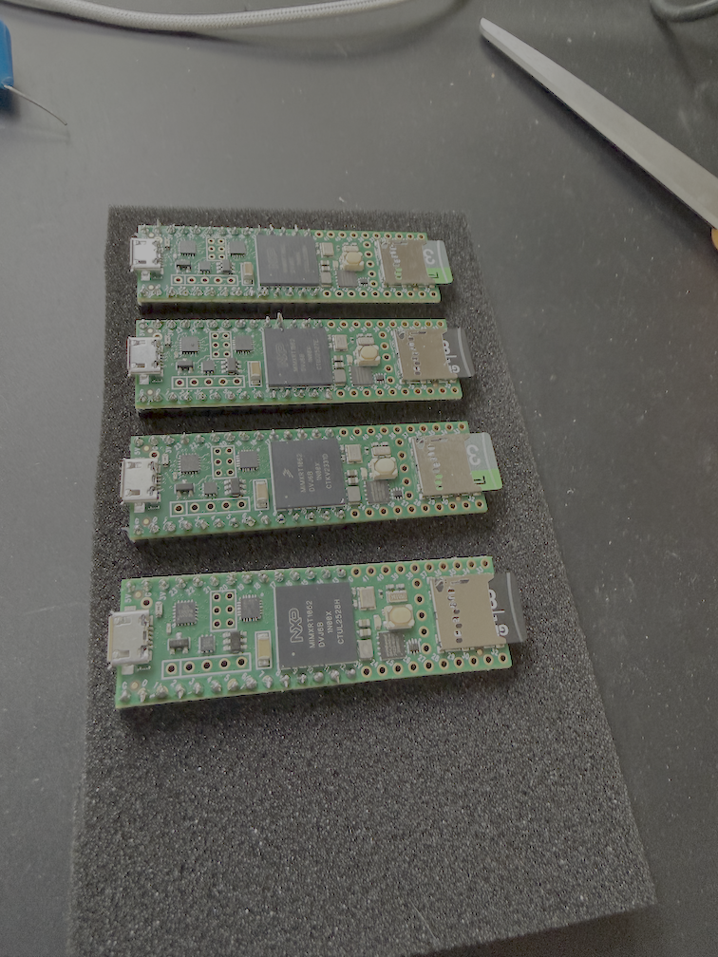

Another thing that might fail is the small transformers inside each controller, which convert from 24V to 12V. These can be replaced just by disconnecting the old and connecting a new one.

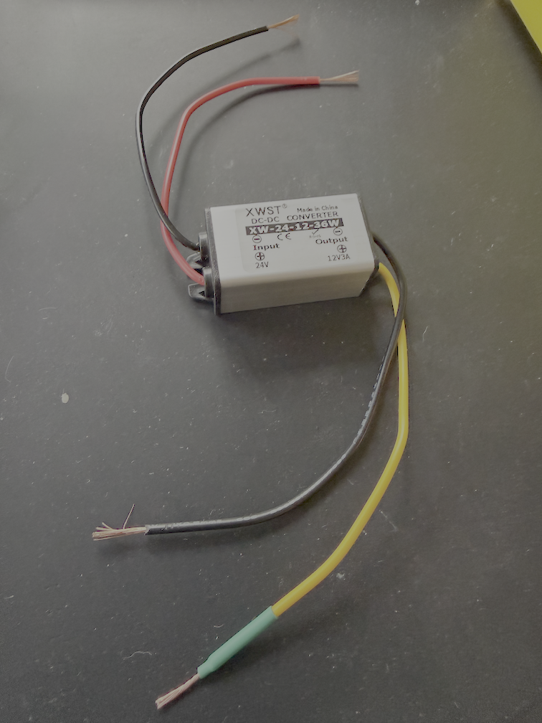

It is also possible, although exceedingly unlikely, that the entire circuit board fails. We have replacements for those, but this is really the least likely failure so only consider replacing it if you’ve tried everything else.

# WIRING INSIDE THE CONTROLLERS

Each of the small controllers has a rat’s nest of wires under the circuit board which looks intimidating.

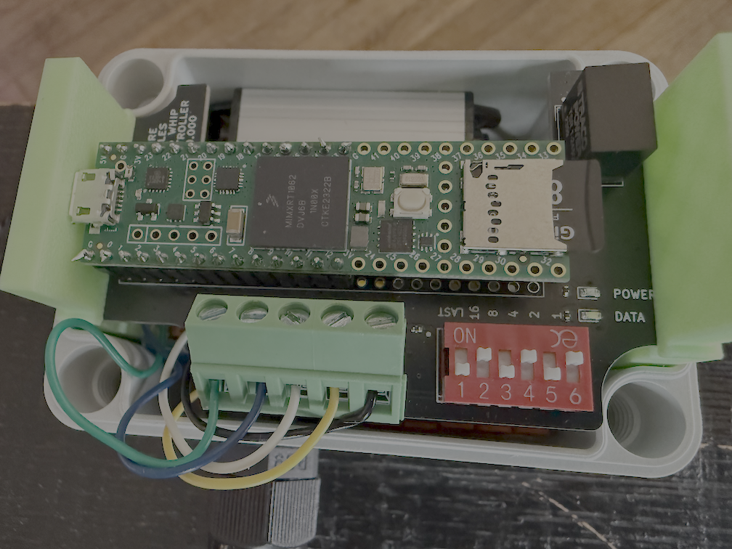 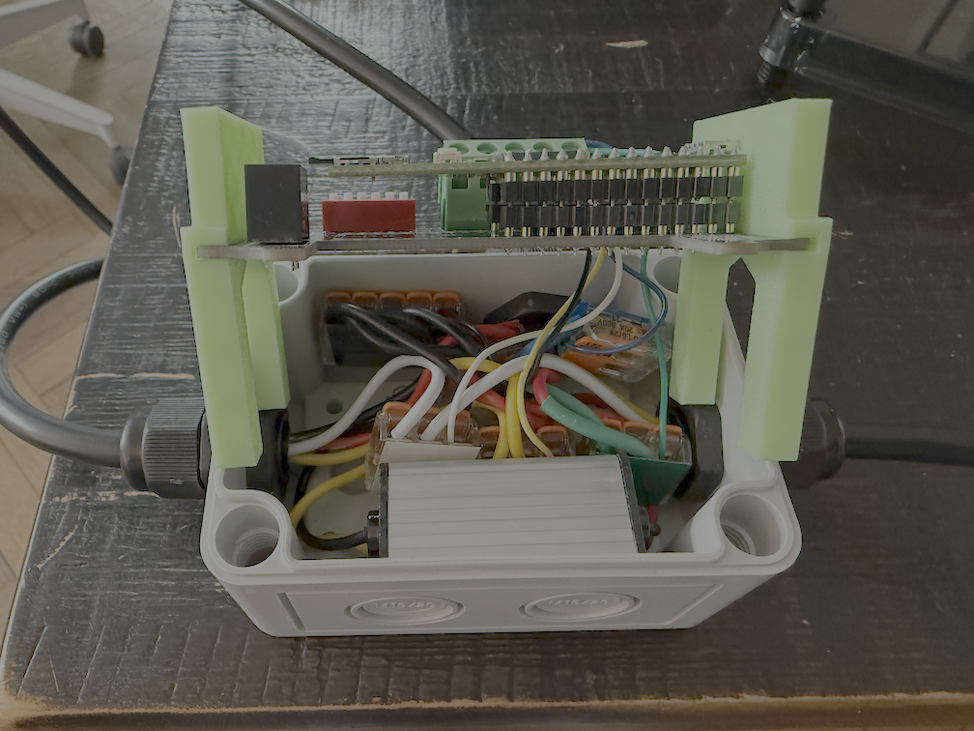

Don’t panic! Just trust the color code. Beneath the circuit board, all the reds are connected to red, black to black, green to green, etc. etc.

# WIRING COLOR CODE

Most wiring in this project follows the following color code:

|  |  |  |
| --- | --- | --- |
| Color | Purpose |  |
| RED | +24 V | Power from main transformers |
| BLACK | GND | DC Ground |
| WHITE | Comm A | Communication between controllers |
| YELLOW | Comm B | Communication between controllers |
| GREEN | +12 V | Lower voltage used for whips and circuit boards. There is a small 24vdc to12vdc stepdown transformer inside every controller. |
| BLUE | Neopixel signal | WS2812 data from circuit board to whip |
| BROWN | AC 120V Hot | Mains power to main transformer |
| LIGHT BLUE | AC 120V Neutral | Mains power to main transformer |
| LIGHT GREEN | AC Earth | Mains earth |